package nov19;
class Vehicle {
void start() {
System.out.println("Vehicle is starting...");
}
}

class Bike extends Vehicle {
@Override
void start() {
System.out.println("Bike is starting...");
}
}

public class Main {
public static void main(String[] args) {

Vehicle v = new Vehicle();
v.start();

Bike b = new Bike();
b.start();
}
}
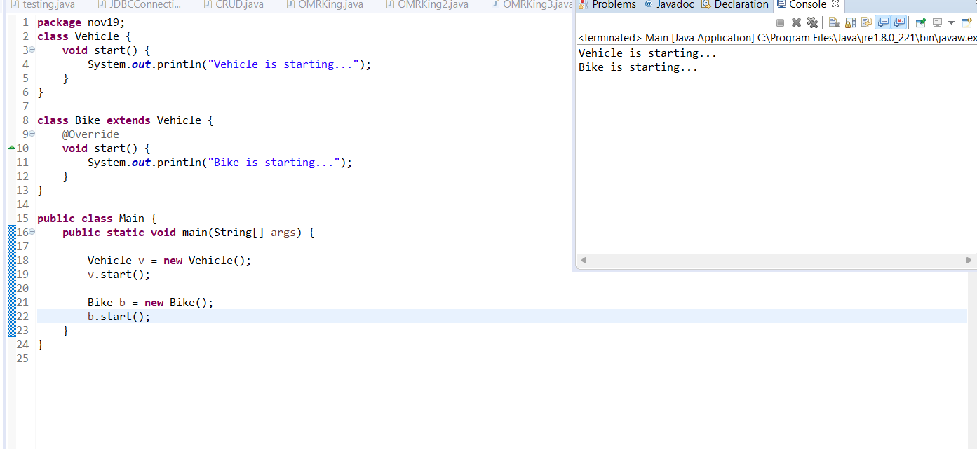
package nov19;
// METHOD OVERLOADING
class Calculator {

void add(int a, int b) {
System.out.println("Sum (int,int): " + (a + b));
}

void add(double a, double b) {
System.out.println("Sum (double,double): " + (a + b));
}

void add(int a, int b, int c) {
System.out.println("Sum of 3 numbers: " + (a + b + c));
}
}
// ENCAPSULATION
class BankAccount {

private String name;
private double balance;

void setName(String n) {
name = n;
}

void setBalance(double b) {
balance = b;
}

String getName() {
return name;
}

double getBalance() {
return balance;
}

void display() {
System.out.println("Name: " + name);
System.out.println("Balance: " + balance);
}
}
// ABSTRACTION USING ABSTRACT CLASS
abstract class Animal {
abstract void sound(); // abstract method

void sleep() { // normal method
System.out.println("Animal is sleeping...");
}
}

class Dog extends Animal {
@Override
void sound() {
System.out.println("Dog barks!");
}
}
// ABSTRACTION USING INTERFACE
interface MyVehicle {
void start();
void stop();
}

class Car implements MyVehicle {

public void start() {
System.out.println("Car is starting...");
}

public void stop() {
System.out.println("Car stopped.");
}
}
// MAIN CLASS
public class Overloading {
public static void main(String[] args) {

// --- METHOD OVERLOADING ---
Calculator c = new Calculator();
c.add(10, 20);
c.add(10.5, 20.5);
c.add(1, 2, 3);

// --- ENCAPSULATION ---
BankAccount acc = new BankAccount();
acc.setName("Aditi");
acc.setBalance(50000);
acc.display();

// --- ABSTRACT CLASS ---
Animal d = new Dog();
d.sound();
d.sleep();

// --- INTERFACE ---
Car v = new Car();
v.start();
v.stop();
}
}
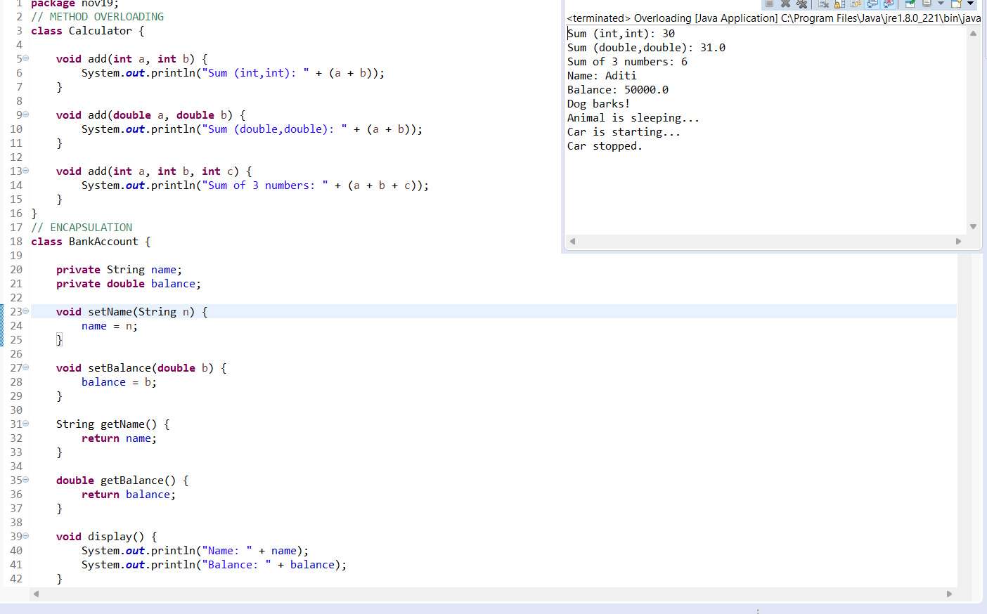
EXCEPTIONS
package nov19;

public class ExceptionDemo {
public static void main(String[] args) {
// 1. ArithmeticException
try {
int a = 10;
int b = 0;
int result = a / b;
System.out.println(result);
}
catch (ArithmeticException e) {
System.out.println("ArithmeticException caught: " + e.getMessage());
}
finally {
System.out.println("Finally executed (ArithmeticException)");
}

System.out.println("----------------------------------------");
// 2. NullPointerException
try {
String s = null;
System.out.println(s.length());
}
catch (NullPointerException e) {
System.out.println("NullPointerException caught: " + e.getMessage());
}
finally {
System.out.println("Finally executed (NullPointerException)");
}

System.out.println("----------------------------------------");
// 3. NumberFormatException
try {
String n = "12A3"; // invalid number
int x = Integer.parseInt(n);
System.out.println(x);
}
catch (NumberFormatException e) {
System.out.println("NumberFormatException caught: " + e.getMessage());
}
finally {
System.out.println("Finally executed (NumberFormatException)");
}

System.out.println("----------------------------------------");
// 4. ArrayIndexOutOfBoundsException
try {
int arr[] = {10, 20, 30};
System.out.println(arr[5]); // invalid index
}
catch (ArrayIndexOutOfBoundsException e) {
System.out.println("ArrayIndexOutOfBoundsException caught: " + e.getMessage());
}
finally {
System.out.println("Finally executed (ArrayIndexOutOfBoundsException)");
}
}
}
